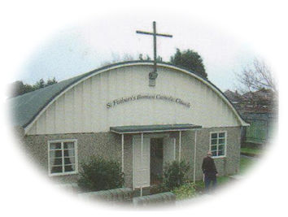
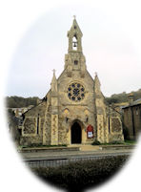
The Parish of The Good Shepherd
St Paul’s Dover & St Finbarr’s Aylesham
St Paul’s Church & Presbytery 103 Maison Dieu Road, Dover CT16 1RU
St Finbarr’s Church, Market Place, Aylesham CT3 3EZ
Tel: 01304 206766 Email dover@rcaos.org.uk

NEW/UPDATED PARISHIONER REGISTRATION FORM

Title: _____ Surname: _______________________________First Name: _________________________________

Home Address: ____________________________________________________________________________

__________________________________________________________ Post Code: ______________________

Date of Birth: ______________________Tel No: ______________________ Mob No: _______________________

Email:

Family members living at your home address:

Name: ________________________________Relationship________________ Date of Birth: _______________

Name: ________________________________ Relationship________________ Date of Birth: _______________

Name: ________________________________Relationship________________ Date of Birth: _______________

Name: ________________________________ Relationship________________ Date of Birth: _______________

Name: ________________________________Relationship________________ Date of Birth: _______________

Name: ________________________________ Relationship________________ Date of Birth: _______________

Name: ________________________________ Relationship________________ Date of Birth: _______________

This completed form should be returned to The Parish Secretary, The Parish of The Good Shepherd, The Presbytery, 103 Maison Dieu Road, Dover CT16 1RU. Email: dover@rcaos.org.uk

The information that you provide on this form will not be transferred to any external third party without your consent. It will be kept confidential and stored securely until such a time as you ask for your personal details to be removed from the Parish Records, upon which your details will be deleted or securely destroyed. If you have any questions about how the details you provide on this form will be used then please contact the parish secretary dover@rcaos.org.uk Tel 01304 206766

A parish of the Roman Catholic Archdiocese of Southwark
CIO Registered Incorporated Charity Number 1173050

