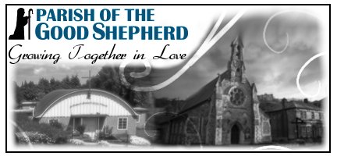
St Paul’s Presbytery 103 Maison Dieu Road, Dover CT16 1RU
St Finbarr’s Church, Market Place, Aylesham CT3 3EZ
Parish Priest: Fr Gabriel Onoyima CSSp 01304 206766 gabrielonoyima@rcaos.org.uk
Asst: Fr Ben Wambua, CSSp 01304 206766 benedictwambuanzioka@rcaos.org.uk
Asst: Fr Jamie Houghton 07955 242324 jameshoughton@rcaos.org.uk
Deacon Barry Barton: 07715 546938 barrybarton@rcaos.org.uk
Parish Secretary: 07936 573155 dover@rcaos.org.uk
St Finbarr’s: aylesham@rcaos.org.uk
Parish website: www.Parishofthegoodshepherd.uk
Parish Giving: www.Parishofthegoodshepherd.uk/giving/
St Paul’s Mass Live Streaming: www.churchservices.tv/dover
https://www.youtube.com/@stpaulsdoverstfinbarrsayle7499/streams



EIGHTEENTH SUNDAY IN ORDINARY TIME – YEAR A
2nd August 2026
Missal P643 Order of the Mass P470

PRIEST CORNER:
We welcome back Fr. Jamie who has been away for the last two months on a well-deserved break. Fr Gabriel will be going for his holiday from the 7th of August until 5th of September. Please keep him in your prayers. In his absence, please contact Fr Benedict as he will be in charge of the parish.

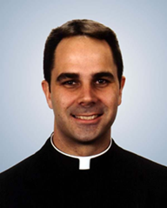
FR. DONALD CALLOWAY, MIC is Vicar Provincial and Vocation Director for the Marian Fathers of the Immaculate Conception. We are privileged to have Fr. Donald visit St Paul’s on Tuesday 18th August at 7pm to speak about The Divine Mercy Message and Devotion. He is the author of 25 books, including Consecration to St. Joseph: The Wonders of Our Spiritual Father. He is a well-known conference speaker on Divine Mercy, the Blessed Virgin Mary, and St. Joseph, and speaks passionately about these topics in his moving conversion story. He leads pilgrimages to Catholic shrines around the world and resides at the Marian House of Studies in Steubenville, Ohio. All are welcome to attend this very special occasion.

GOSPEL REFLECTION: 18^{h} Sunday in Ordinary Time Year A
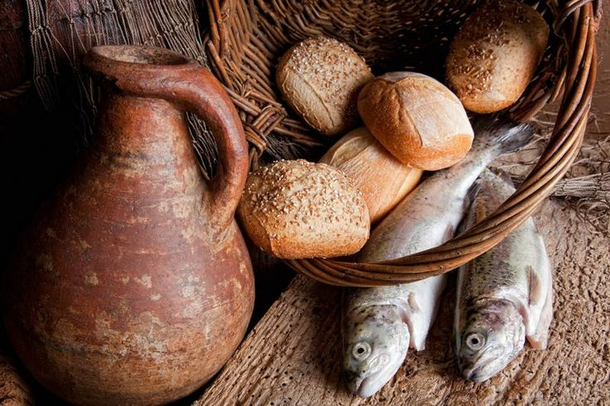
We may not accurately imagine the pain of a mother whose children are hungry and has no hope from where to get the next meal. How often have we come to a difficult moment in our lives when all hopes seem to fade away? How did a mother of hungry children survive the ordeal of not having food, how did we recover from those difficult situations? We may not be so sure of what brought the changes but looking at the invitation from the prophesy of Isaiah, come all who hunger and thirst… God provides for us even when we are not aware of how it all happened as he knows our needs. Jesus feeding the great number of people is one of the miracles that shows how God can help even when we have not prayed for our needs. How could this have happened if the people were not following Jesus? Remarkable things happen in our life when we put our trust and hope in Jesus. How he does it, we do not know and may never know. All we can do is to be present with Jesus.

PLEASE PRAY FOR Roselene Mary Hindle who passed away recently. We also pray for her husband Peter and family in their loss. Roselene’s funeral service will take place on Friday 7thAugust 2026 at Barham Crematorium at 12noon. Also Robert Yore, formally from Aylesham, who has passed away in Australia. We pray for his family during this difficult time. May Roselene and Robert Rest in Peace and Rise in Glory, Amen.

CELEBRATION FOR 90-YEAR-OLD. Sheila would like to express extreme gratitude on behalf of all those who attended the wonderful celebration for 90-year-olds last Sunday, especially to Fr Gabriel, Deacon Barry & Sue who arranged the wonderful afternoon tea of Jelly, Ice cream, Strawberries and Cake. Love and God bless to you All.

WORLD DAY FOR GRANDPARENTS AND THE ELDERLY 2026: REPORT OF CELEBRATION
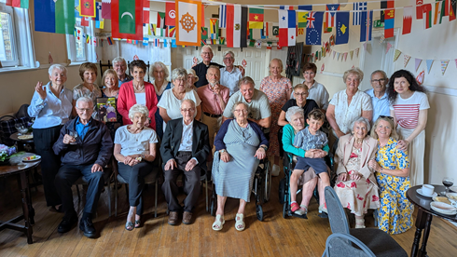
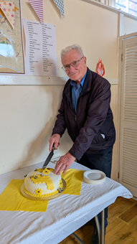
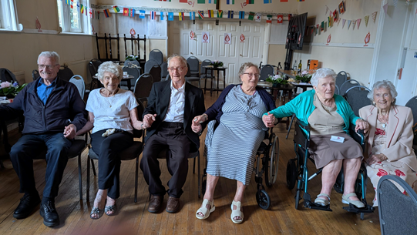
Last Sunday, 26th July, the parish celebrated the 6th World Day for Grandparents and the Elderly by concentrating on those parishioners from St Paul’s and St Finbarr’s who are 90 years old in 2026 or older. Celebrations took 2 forms. A Mass in St Paul’s Church at which Fr Gabriel presided followed by a social in the hall for the nonagenarians, their family representatives and friends. Deacon Barry's homily addressed Pope Leo 14th chosen theme for the day of 'I Shall Never Forget you (Isaiah 49:15). A lighted candle symbolised the bidding prayers offered. A bee symbolised God's blessing of grandparents. A vase of sunflowers symbolised faith and devotion. Fr Gabriel said the Grace. Strawberries, ice cream and jelly were enjoyed by all with lashings of tea. A toast of thanksgiving for the lives of the nonagenarians was given followed by cutting of the celebratory cake, with its decoration of bees and sunflowers. Special thanks go to all those parishioners who helped to make the social such a great success. Last Sunday's homily will also delivered today at St Finbarr’s. Deacon Barry.

REQUESTING MASS FOR A PARTICULAR INTENTION
It is a long-established and laudable Catholic custom to ask that Mass be offered for a particular intention. Every Mass is offered for the glory of God and the salvation of the world; nevertheless, the priest may also offer the Mass for a specific intention. In this parish, Mass intentions are usually published in the newsletter. Anyone may request that Mass be offered for a particular intention. Masses are commonly offered for the welfare of an individual or family, in thanksgiving, for a special need, or for the repose of the soul of someone who has died. When requesting a Mass, it is customary to make an offering as a sign of one’s particular participation in the offering of the Mass and in support of the Church’s ministry. This offering is not a payment for the Mass, and no one is obliged to make one. The suggested offering is £10; some give less, some give more, and some are unable to give anything. Please never feel that a Mass cannot be offered for your intention because of financial difficulty. The grace of the Mass is never bought or sold. Its true price has already been paid for us in the saving death and resurrection of the Lord Jesus. Mass intention envelopes and request forms are available at the entrance to the church.

FATHER JOHN PANARIO. Fr John’s last Sunday morning Mass as Parish Priest of Our Lady of Dover will take place on Sunday 30th August. There will be a buffet lunch in Our Lady’s Hall after the 10.30am Mass. All are welcome to attend. If you wish to donate towards a gift for Fr John please put in an envelope clearly marked ‘For Fr Panario Collection’ and place in the offertory collection here at St Paul’s or St Finbarr’s or put through the door of the presbytery at St Paul’s. Anyone who would like to bring food and/or help with the buffet at Our Lady’s on the day please speak to Pauline 07990 982552. Father Andrew Bishop will be taking over as Parish Priest of Our Lady’s in September. Fr. John will be living in Dover so will not be far away.

ST PAUL'S BIBLE STUDY, SUMMER BREAK The last study, before the summer break, is Thursday 30th July. The group will reconvene on Thursday 10th September.

ST PAUL’S FIDES PRAYER GROUP will be taking a break for the summer until after the new school term commences in September. Date to be confirmed.

MUSTARD SEEDS Children’s Liturgy at St Paul’s is taking a break over the summer. We will be back Sunday 6th September at 11am Mass.

FOUNDATION GOVERNORS. St Joseph’s School, Aylesham are looking for Foundation Governors.
If anyone is interested, please contact Philip by email Philip.Smye-Rumsby@st-josephs-aylesham.kcsp.org.uk

CONFIRMATION 2026. Sunday 22nd November at 11am Mass. Parents of children, 13 years upwards, who wish to be confirmed, please pick up an application form either from the Parish Office or from Theresa Wells after 9am Mass on Sunday or Anne Rowe at St. Finbarr’s. We want to start our Confirmation Classes soon.

COME TO THE CELEBRATE FESTIVAL - A FAITH-FILLED EVENT FOR ALL THE FAMILY.
Runs from 15-19 August, at Worth School, West Sussex. Hear inspiring speakers such as Fr Roberto Pasolini (Preacher to the Pope), David Wells and Johannes Hartl, experience beautiful masses, pray in Worth Abbey, fun and formation for children and young people aged 3-24 each day of the festival, and relax in the beautiful Sussex countryside. Camp in our festival field or stay in school accommodation. Weekend tickets also available.
For more information visit www.celebratefestival.org

ENJOYING GOD’S CREATION: A summer retreat day at Minster Abbey on August 29th led by Eddie Gilmore. Contact: gileag@gmail.com www.eddiegilmore.org

THE GROWING IN FAITH TOGETHER FOR MARRIED AND ENGAGED COUPLES is an ONLINE course, which has been developed in collaboration with the Southwark Marriage and Family Life team, the Agency for Evangelisation and Sycamore, a programme about the Catholic faith by Fr Stephen Wang, Bishop-Elect of Arundel and Brighton. Save the dates: September 8th, 15th, 22nd &29th. Growing in Faith Together consists of four one hour-long sessions via Zoom and is a wonderful opportunity for:
· Married couples to enrich their friendship and love.
· Engaged couples who want to continue exploring their faith together
The next course begins on Tuesday September 8th at 8.30pm. For further information and to book a place, please contact Carole on mflkent@rcaos.org.uk

Parish of the Good Shepherd Dover and Aylesham
‘Called to Bear Fruit’: Parish Renewal, 2026
Mustard Seed Youth Prayer Warriors Holy Rosary | Saturdays 3pm  1st August 2pm Film Show in Upper Hall | St Paul’s, Dover
Mustard Seed Children’s Liturgy | First and Third Sundays 11am  Will resume on 6th September | St Paul’s Upper Hall, Dover
St Finbarr’s Children’s Liturgy | Sunday 11am | St Finbarr’s, Aylesham
St Jude’s Prayer Group | Third Monday 2pm – 3pm | St Paul’s Hall, Dover
‘Familia Una’ Adult Youth Group | Sundays 6pm  Will resume in September | St. Paul’s Upper Hall, Dover
Fides Prayer Group St Paul’s | Wednesdays 6:40pm for 7pm  Will resume in September | St Paul’s Hall, Dover
Holy Rosary | Thursdays 9.30am | St Paul’s, Dover
Bible Study | Thursdays 10.30am  Will resume on 10th September | St Paul’s, Dover

CATECHISM –

The signs of bread and wine

At the heart of the Eucharistic celebration are the bread and wine that, by the words of Christ and the invocation of the Holy Spirit, become Christ's Body and Blood. Faithful to the Lord's command the Church continues to do, in his memory and until his glorious return, what he did on the eve of his Passion: "He took bread...." "He took the cup filled with wine...." the signs of bread and wine become, in a way surpassing understanding, the Body and Blood of Christ; they continue also to signify the goodness of creation. Thus, in the Offertory we give thanks to the Creator for bread and wine, fruit of the "work of human hands," but above all as "fruit of the earth" and "of the vine" - gifts of the Creator. the Church sees in the gesture of the king-priest Melchizedek, who "brought out bread and wine," a prefiguring of her own offering. (CCC1333)

Please Pray for those who are unwell:

St Finbarr’s: Charlotte, Elisabet Sulianti, Gabriela le Bohec, Charlie Golden, Tina Isaacs, Ray Deverson, Lucy Purbrick, Amanda Dennis, Jadon Michael Kalp, Denise Mastro, Tara Conklin, Jamie Chitwood.

St Paul’s: Sheila Henneker, Keely Cookson, David Underdown, Sr. Jennifer Sanders, Carol Manton, Oliver O’Connor, Helen Scopes, John Doyle, Maria Frost, Roz & Rob Pain, Rosa Mazzitelli, Sr Rani Xavier, Thanima Jayan, Janice & Livra Fernandes, Catriona Stark, Mary Pressnell, Gaby Anaya Amor, Pat Evans, Shirley Lazarus, Shirley Jefford, Gail White, John & Joyce Nix, Bailey Turner, Peggy Merrell, Ryan Whittall, Jean Ann Dowle, Norman Woolhouse, Ted Peel, Christopher Browne, Angela, Alice Wilson, Angela Henbrey, Madison Woodall, Elisa Gomez Melero, Ann Tomalak, Emin Jain, Pat & Patricia Sherratt, Chris Roy,.

Please Pray for those whose death anniversaries occur this week:

St Finbarr’s: Mabel Thatcher, Brian Lawrence West, Emil Bozzay, Susannah McLelland, Alan Lonie, Peter Murphy, Robert Brendan Dash, Peter Hugh Alfred Kearon.
St Paul’s: Basil Perry, Vera Salmon, Betty McWilliams, Roger Marsden, Sister Mary Hayes DC, Ellen Bartlett, Fr Henri Schembri SJ Maurice McDade, John Sullivan, Joyce Naylor, Mary Wall, Des Murray, Robert Nolan, Brendan Townhill, Frances Cowan.

EVENTS THIS WEEK AT ST. FINBARR’S
- Accommodating
- Knows his/her priorities
- Interior life
- Lectio divina
- Visit to the Blessed Sacrament
- Holy Hour
- Formed missionaries
- Can see the relation of the Word of God to their lives
EIGHTEENTH SUNDAY IN ORDINARY TIME | Sunday  2nd August | 11am | Mass for Hannah Wall ‘F’
THE DEDICATION OF THE BASILICA OF SAINT MARY  MAJOR | Wednesday  5th August | 10am | Mass for Children of St Finbarr’s
NINETEENTH SUNDAY IN ORDINARY TIME | Sunday  9th August | 11am | Mass for Missionaries
EVENTS THIS WEEK AT ST. PAUL’S
SAINT ALPHONSUS LIGUORI, BISHOP AND DOCTOR OF THE  CHURCH | Saturday  1st August | 10am  2pm  3.30pm  5pm  6pm | Mass in St Edmund’s Chapel for G/E Theresa (Sheila)  Junior Mustard Seeds Movie Afternoon in the Upper Hall  THE MEDAILLE TRUST & CARITAS SOUTHWARK ROADSHOW IN THE PARISH HALL  Confessions in the church (until 5.45pm)  Mass for The Work of The Medaille Trust & Caritias Southwark
EIGHTEENTH SUNDAY IN ORDINARY TIME | Sunday  2nd August | 9am  11am  3pm | Mass for Parishioners (Sheila)  Coffee after Mass  Mass for G/E The Dowle Family  Exposition and Divine Mercy Chaplet
 | Monday  3rd August | 10am | Mass for G/E Sheila’s Family
SAINT JOHN VIANNEY, PRIEST, MEMORIAL, PATRON OF PARISH PRIESTS | Tuesday  4th August | 10am | Mass for Rafaela Morris RIP (Tim)
THE DEDICATION OF THE BASILICA OF SAINT MARY  MAJOR | Wednesday  5th August | 10am  5.30pm | Mass for Robert MacKenzie Birthday (Keith & Theresa)  Exposition and Holy Rosary until 6.30pm
THE TRANSFIGURATION OF THE LORD | Thursday  6th August | 9.30am  10am | Holy Rosary  Ordinariate Mass for G/E Sheila’s Friends
SAINT SIXTUS II, POPE, AND COMPANIONS, MARTYRS OR  SAINT CAJETAN, PRIEST | Friday  7th August | 10am | Mass for Conversion of Unbelievers
SAINT DOMINIC, PRIEST, MEMORIAL | Saturday  8thAugust | 10am  5pm  6pm | Mass in St Edmund’s Chapel for Those with Terminal Illnesses  Confessions in the church (until 5.45pm)  Mass for Alan Corby RIP (Roger & Maureen)
NINETEENTH SUNDAY IN ORDINARY TIME | Sunday  9th August | 9am  11am  3pm | Mass for Catriona’s 30th Birthday (Sheila)  Coffee after Mass  Mass for People of the Parish  Exposition and Divine Mercy Chaplet
PARISH SAFEGUARDING REPRESENTATIVES CONTACT EMAIL
Stephen Carton for St Finbarr’s ayleshamsg2@safeguardrcaos.org.uk
Zoroaster Bordios for St Paul’s doversg2@safeguardrcaos.org.uk
For a newsletter emailed weekly, or to suggest articles/additions, contact the Editor: dovernewsletter@rcaos.org.uk
Newsletter items received after 6pm Thursday may not be included that week. The Editor reserves the right to edit articles.
A Parish of the Roman Catholic Archdiocese of Southwark CIO Registered Incorporated Charity Number 1173050

Readings for Sunday
2nd August 2026
First reading
Isaiah 55:1-3 ·
‘Come and eat.’
Thus says the Lord:
‘Come, everyone who thirsts, come to the waters;
and he who has no money, come, buy and eat!
Come, buy wine and milk without money and without price.
Why do you spend your money for that which is not bread,
and your labour for that which does not satisfy?
Listen diligently to me, and eat what is good,
and delight yourselves in rich food.
Incline your ear, and come to me;
hear, that your soul may live;
and I will make with you an everlasting covenant,
my steadfast, sure love for David.’
________
Responsorial Psalm
Ps 145(144):8-9. 15-16. 17-18. ℟ cf. 16
You open your hand and fulfil us, O Lord.
The LORD is kind and full of compassion,
slow to anger, abounding in mercy.
How good is the LORD to all,
compassionate to all his creatures.
You open your hand and fulfil us, O Lord.
The eyes of all look to you,
and you give them their food in due season.
You open your hand and satisfy
the desire of every living thing.
You open your hand and fulfil us, O Lord.
The LORD is just in all his ways,
and holy in all his deeds.
The LORD is close to all who call him,
who call on him in truth.
You open your hand and fulfil us, O Lord.
________
Second reading
Romans 8:35, 37-39 ·
‘Nothing in all creation will be able to separate us from the love of God in Christ.’
Brothers and Sisters: Who shall separate us from the love of Christ? Shall tribulation, or distress, or persecution, or famine, or nakedness, or danger, or sword? No, in all these things we are more than conquerors through him who loved us. For I am sure that neither death nor life, nor angels nor rulers, nor things present nor things to come, nor powers, nor height nor depth, nor anything else in all creation, will be able to separate us from the love of God in Christ Jesus our Lord.
________
Gospel Acclamation
Matthew 4:4b
Alleluia, alleluia.
One does not live by bread alone,
but by every word that comes forth from the mouth of God.
Alleluia.
________
Gospel
Matthew 14:13-21
‘They all ate and were satisfied.’
At that time: When Jesus heard of the death of John the Baptist, he withdrew in a boat to a desolate place by himself. But when the crowds heard it, they followed him on foot from the towns. When he went ashore he saw a great crowd, and he had compassion on them and healed their sick. Now when it was evening, the disciples came to him and said, ‘This is a desolate place, and the day is now over; send the crowds away to go into the villages and buy food for themselves.’ But Jesus said, ‘They need not go away; you give them something to eat.’ They said to him, ‘We have only five loaves here and two fish.’ And he said, ‘Bring them here to me.’ Then he ordered the crowds to sit down on the grass, and taking the five loaves and the two fish, he looked up to heaven and said a blessing. Then he broke the loaves and gave them to the disciples, and the disciples gave them to the crowds. And they all ate and were satisfied. And they took up twelve baskets full of the broken pieces left over. And those who ate were about five thousand men, besides women and children.
Act of Spiritual Communion

My Jesus, I believe that You are present in the Most Holy Sacrament. I love You above all things and I desire to receive You into my soul. Since I cannot at this moment receive You sacramentally, come spiritually into my heart. I embrace You as if You were already there and unite myself wholly to You. Never permit me to be separated from You.

