

The Parish
Of
The Good Shepherd

Please reflect upon the following:

- How am I using my time, talents and treasure to glorify God and benefit my Parish community?

- Does my financial contribution to the Parish reconcile my means with its needs?

- Do I give regularly, using a standing order or weekly envelopes or via CollecTin?

- Do I give efficiently, using Gift Aid if I pay UK tax, to ensure that my Parish gets the most out of my contributions?

- How can I share my time and talents with my Parish community?

Next week you will be able to :

- Sign up to share your time and talents in service to your Parish.
- Review & renew the amount you currently give.
- Sign up to Gift Aid your donations if you pay UK tax.

- Make your offering by Standing Order (If you would like assistance with completing the form, please bring your bank details (Acct no. & Sort code) with you to Church next week, when a volunteer will be glad to help)

However you decide to help, we are grateful.

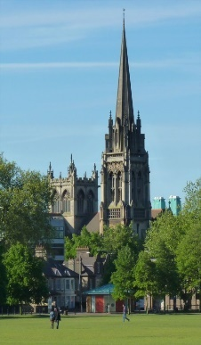



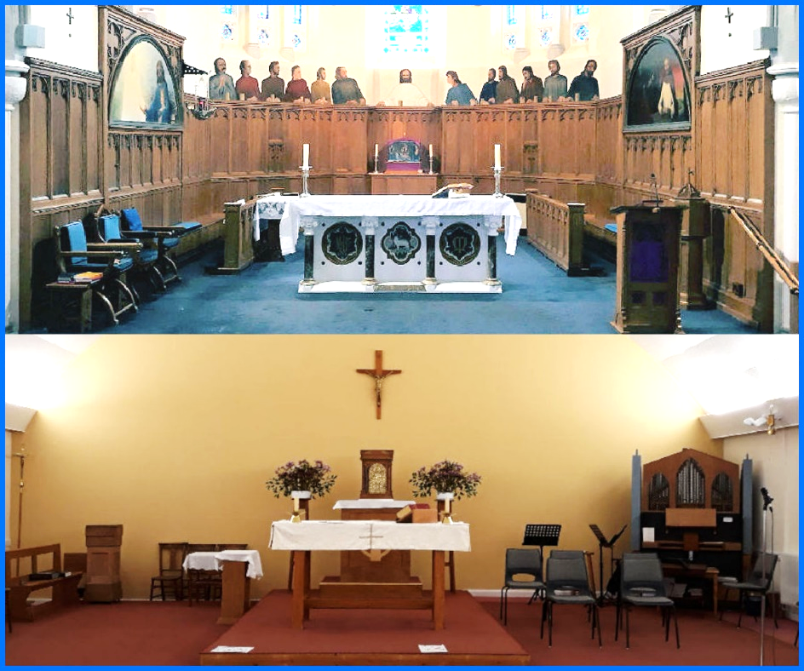

Our Parish
Our Responsibility

ROMAN CATHOLIC ARCHDIOCESE OF SOUTHWARK
Registered Charity Number 1173050
“For, as I can testify, they voluntarily gave according to their means, and even beyond their means.” – Corinthians 8:3

If you have any questions, please ask a volunteer after Mass or contact:
Parish Priest: Fr. Gabriel Onoyima
Address: 103 Maison Dieu Road, CT16 1RU
Tel: 01304 206766
Email: dover@rcaos.org.uk
Website: www.parishofthegoodshepherd.uk

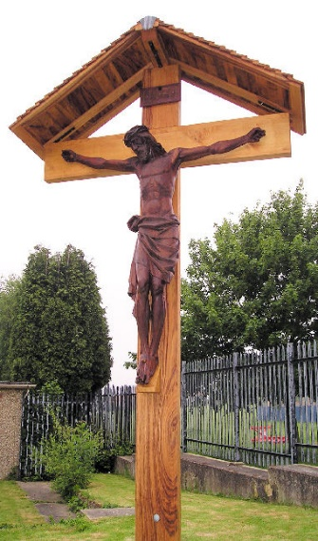
All we have comes from God, so we are His Stewards

Whether it is the gift of our faith, our friends and family, our skills, possessions, or the gift of life itself!
So how do I respond? Do I give thanks to God and honour Him through how I use these gifts? Regularly reflecting on my blessings and renewing my commitment to the Faith through my giving is therefore an important part of my personal spiritual growth and discipleship.

has a rich history as the spiritual centre in our lives. As Stewards responsible for the gifts received from God, we must look after our beautiful churches & pass them on to future generations in excellent condition.
The Parish of the Good Shepherd

Like any household, our Parish has to:

How we operated in 2025

Income |  | Expenditure
Offertory (Gift Aid Envelopes) | £9,555 | Parish Ministry | £32,402
Offertory (Loose Cash) | £25,619 | Heat, Light, Water, Council Tax & Insurance | £30,901
Offertory (Standing Order) | £41,546 | Diocesan Assessments | £27,836
Offertory (Card) | £8,999 | Office & Administration | £35,384
Third Party Collections | £10,694 | Donations for third party collections | £12,980
Specific donations & Gift Aid | £35,219 | Supplies, Maintenance, Facilities & Equipment | £66,691
Rental Income | £14,360 | Property Repairs & Renewals | £22,346
Other Parish Income- Incl. Fundraising, Poor Box, Repository, Candles Sundry | £24,773 | Other Parish Expenses - incl. Candles, Repository, Parish Activities, Fundraising | £6,846
Total | £170,765 | Total | £235,386
Savings (£) | -£64,620 | Savings Rate (%) | -38%

- Cover day-to-day running costs.
- Pay for building costs & repairs.
- Support Parish Programmes and Projects.
- Save a % of our income for emergency repairs
& future projects.

Whenever we give, we grow each time we:
- Joyfully recall that all we have comes from God;
- Declare our trust in His provision and care;
- Take one step forward in our personal faith journey;
- Share in the joy of giving and seeing the amazing fruits it brings.

Gift Aid is easy to do, doesn’t cost you
a penny and helps run and sustain
our Parish, its buildings and its contents.
If you pay tax, you can easily Gift Aid, which automatically increases your donation by adding a quarter more at no cost to you.
Gift Aid allows us to receive an extra 25p for every £1 you donate!


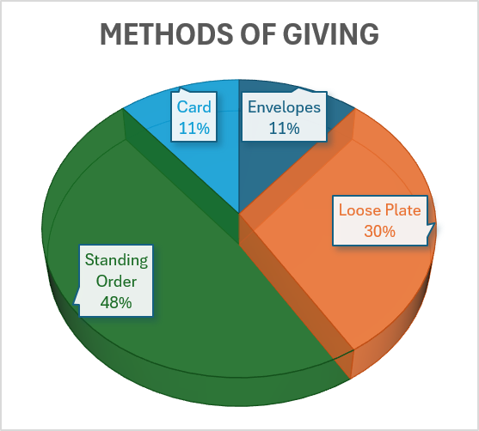
Standing Order is one of the best ways
to support our Parish!
A standing order is an instruction to your bank to make regular fixed payments to our Parish.
This provides secure, regular income that is easy to Gift Aid, easy to reconcile and takes less time than counting loose change each week. You do not need to worry about getting cash each week for Mass.
You can set up your Standing Order -
all you need is your account number & sort code.

Thanks to your support, our churches and Parish buildings are in good condition, having spent over £51,185 in the last 3 years on necessary repairs and maintenance. We are planning a major improvement at St Finbarr’s and a major project for the Hall in Dover.

