#

The Parish of the Good Shepherd
Guidance for completing this form
- Make your offertory donation by Standing Order – this is one of the best ways you can support our parish. If you already have a standing order, and wish to change the amount you give, please complete the right hand side of the form which will instruct the bank to cancel your existing standing order and replace it with your new commitment. If you have internet banking you can do this yourself online.
- Make your donation by weekly donation envelope – please tick this box if you wish to start using weekly donation envelopes OR if you wish to continue using your current batch of envelopes. You do not need to gift aid to donate by envelope.
- If you would like us to send you information about leaving a gift in your Will to the church, or to receive information on Estate Planning and Will Writing services please tick the box.
- Gift Aid Declaration: At the bottom of this form is the Gift Aid declaration. Gift Aid enables our parish to claim an extra 25p to every £1 that you give (at no extra cost to yourself). If you are a UK Income or Capital Gains tax payer, please sign up to Gift Aid.
Please renew your Gift Aid declaration today, to ensure we have your most up-to-date details and Gift Aid status. Please sign the declaration in ONE NAME ONLY. If you would like to backdate your Gift Aid donations, please insert the year from which you are eligible to backdate. You can backdate up to a maximum of 4 years.
- Volunteer Insert: Here you will see there is the opportunity to sign up to a variety of volunteering opportunities in the parish. We shall contact you in the coming weeks to provide you with more information. I welcome you to mention if you have any other talents that could be of use to us as a parish community.
When you have completed this form please return it to the parish by either posting it in the collection boxes at the end of next week’s mass, or post to: St Paul, 103 Maison Dieu Road, Dover, Kent CT16 1RU. The form can also be emailed to dover@rcaos.org.uk

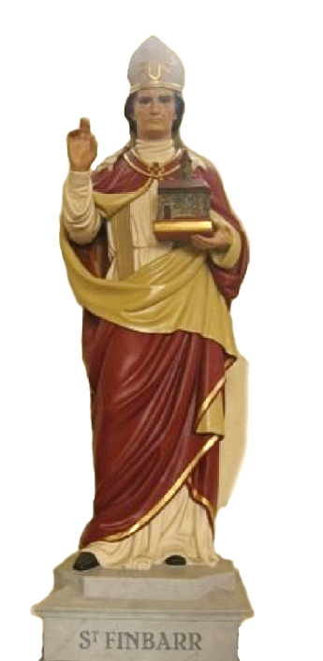
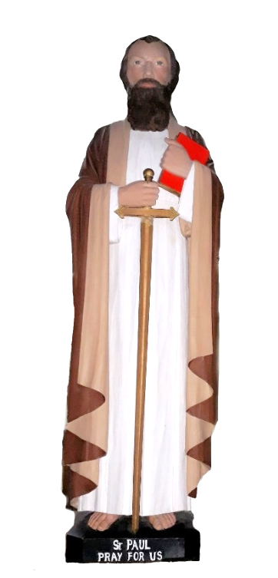

Growing Together in Love

My Parish Commitment

ROMAN CATHOLIC ARCHDIOCESE OF SOUTHWARK

Registered Charity Number 1173050
….


My Details: [PLEASE USE BLOCK CAPITALS]

Title ……………. Full Name:………………………………………………………………………………………………………….

Address ………………….……………………………………….………...………………………………………………………….….

……………………………………………………………………………….………..Postcode ……..…………………………………

Tel…………………………………………………………………………………………………………………………………..…………
..
Email ………………….……………………………………….………...………………………………………………………….……..
By giving us your telephone or email, you consent to being contacted via this method.

I would like to support the work & mission of my parish by: [TICK]

- Standing Order: £_____.____ every Month Quarter Year

Please either: Complete the form (right ) and hand in to collecting volunteers or the parish office. The archdiocese will set up your standing order on your behalf.

Or tick HERE to let us know you have set up your standing order yourself via online banking, using the payee details opposite.

- Weekly donation envelopes
- Please send information about leaving a gift in my Will to the church.

Gift Aid Declaration: UK TAX PAYERS: Sign up to Gift Aid HERE.

I wish to Gift Aid [Please] I would like the Archdiocese of Southwark to treat all qualifying donations I make today, and any donations I make in the future or have made in the past 4 years, until I notify you otherwise, as Gift Aid donations. I am a UK taxpayer and understand that if I pay less Income tax and/or Capital Gains Tax then the amount of Gift Aid claimed on all my donations in that tax year it is my responsibility to pay the difference. If you would like to backdate your Gift Aid donations, please insert the year from which you are eligible to backdate. You can backdate up to a maximum of 4 years: Year………….

Signed: ……….……………………………………………………………………….. Date: ..………………………………………………………..
4
- I am setting up a NEW Standing Order
- I am updating my EXISTING Standing Order
Standing Order Instruction

- Account details

To the Manager of ……………………………………………………….…….…Bank / Building Society

Please set up the following Standing Order and debit my/our account accordingly

Name of account holder………………………………………………………………………………………………………

Sort code 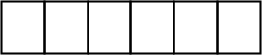 Account Number 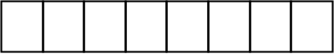

2. Payee details

Please pay the NATWEST Account Number: 79114784 Sort Code: 60 50 01

For the credit of RCAS Dover

3. About the payment

Payments to be made: Monthly Quarterly Yearly

Date Amount

1st Payment (please allow 30 working days)  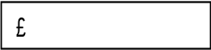

Thereafter make payments on the …………..day until further notice (payments will be made until you cancel this instruction)

NOTE TO THE BANK:
This Standing Order is to REPLACE any existing Standing Order to the above bank account.

Please print DONOR’S SURNAME AND INITIAL on the bank statement.

4. Confirmation

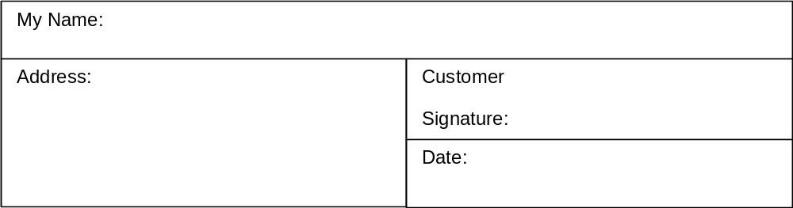

2
.



GAD No:
Env No:
Protecting your privacy – Archdiocese of Southwark – Registered Charity Number 1173050
Your personal details and donations will be stored securely on the Archdiocese of Southwark’s database. We comply with data protection regulation and the Fundraising Regulator’s code of practice. We will never sell or disclose your data to third parties. We will use your details to administer your gifts, occasionally send you news on the work of the Church, and give you the opportunity to support appeals. We only share information with external organisations working on our behalf or when required by law (e.g. to claim Gift Aid). You can read our full privacy policy on https://rcaos.org.uk/diocese/policies. If you do not wish to receive communications, please tick this box

Parish Code:
For official use only
Parish Code:
For official use only

